Cloud Integration Solutions for Enterprise
Did you know, 61% of companies migrated their workloads to the cloud in 2020? As data is no longer stored exclusively on-premises, this transition has overloaded APIs, resulting in a surge of endpoints and a fragmented technological infrastructure. As a result, enterprises find it challenging to connect dynamic applications, services, and data.

With companies moving their applications to the cloud, it is becoming difficult to integrate all these apps efficiently. There’s a need for an integration solution that enables effective information sharing, so that data does not remain trapped within each application or database.
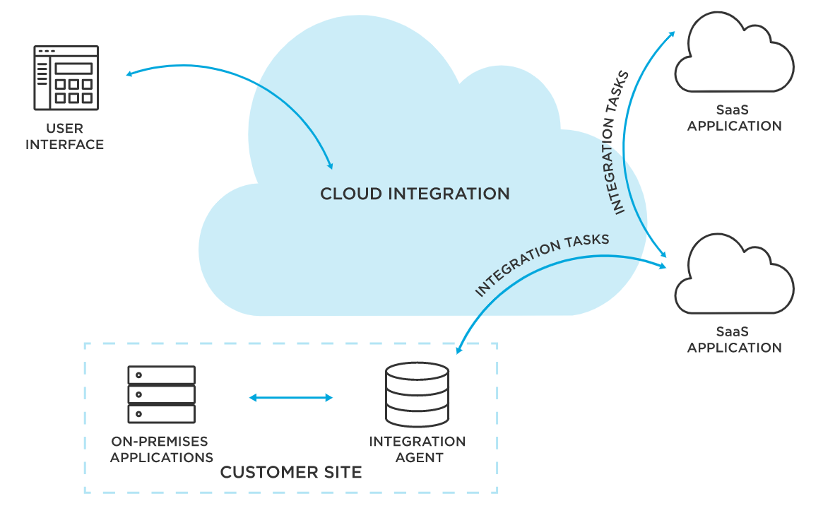
Source: TIBCO

Let’s take a look at some of the cloud integration solutions that help prevent data silos, streamlining the sharing of information and intelligence to other aspects of the business.

Top 3 Cloud Integration Options
One of the biggest software integration challenges today is the decentralized nature of the cloud, especially when you have to integrate applications to optimize business processes or get real-time access to information across several systems and providers.

Here are some of the commonly used types of cloud integration solutions that can help you streamline your integration process.

1. Integration as a Service (IAAS)
Integration as a Service provides connectivity to backend systems, sources, files, and operational applications by implementing well-defined interfaces, web services, and calls between applications and data sources. Moreover, it enables integration across the cloud, allowing real-time data sharing between systems and third-party vendors.

Although IAAS providers secure the infrastructure, companies are responsible for anything they host, making them vulnerable to security risks. Moreover, vendor outages can make users unable to access their information for a while.

2. Point-to-Point Integration
Point-to-point integration uses middleware to allow information sharing between two systems. The middleware simplifies both the data transformation and the process of transporting the data.

To create custom point-to-point integrations, you need to hire a developer, which costs you time and money. Moreover, if one application changes, the developer has to modify the custom code between each connection it supports. Doing so incorrectly can put the business processes and applications the integration supports at risk.

Furthermore, as the number of integrations increases, the more complex an environment becomes. Ultimately, it becomes what is known as “spaghetti architecture”, which impedes an enterprise's ability to quickly decode and transform its applications and data to meet ever-evolving needs.

3. Integration Platform as a Service (iPAAS)
An iPAAS is a platform that standardizes how applications are integrated into an enterprise, making it easier to automate business processes and share data across applications.

Your business needs a cloud application integration solution that can serve as an integration platform and provide seamless connectivity. This is where an iPAAS can help as it provides businesses with an end-to-end integration solution that orchestrates disparate components easily and efficiently.
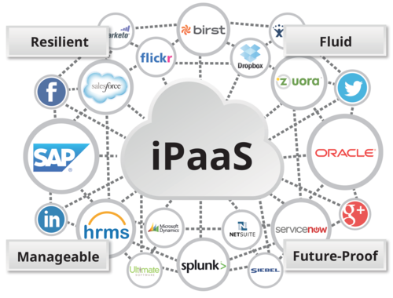
Source: Cloud Elements

What to Look for When Choosing an iPAAS Solution?
The following are a few key considerations you should keep in mind when choosing an iPAAS solution.

- Functionality – Does the solution support hybrid or multi-layer architectures both on the cloud and on-premises? Does it work seamlessly with other software vendors? Does it offer language support?
- Scalability – Is the solution capable of growing along with your business needs? Is it easy to update or add on new features?
- Security – Is your data going to be safe on the platform? Can it store connection info on a local server agent or just the cloud? Does it have the on-prem ability to tunnel all communication through your managed infrastructure?
- Accountability – What kind of experience does it offer as a migration tool (including CPQ)? Can the supplier implement all applications (such as Salesforce, NetSuite, Priority, etc.)?
- Support – Does the iPAAS provider offer dedicated support to each customer? Is their technical support staff available 24/7? Do they offer remote or face-to-face support?

Conclusion
IConduct’s iPAAS simplifies integration between hybrid cross-platforms processes. It helps you focus on the business flow and not on technology and infrastructure. Moreover, it provides complete flexibility in defining automatic business processes and quickly adapts to your fluctuating business needs.

Get a demo to learn how IConduct’s iPAAS can facilitate your cloud integration journey.

